SOUTHERN CATTLE SALE SCHEDULE
2018/19

Monday | Tuesday | Wednesday | Thursday | Friday
Pakenham – D/W  Casterton - S/Oct  Casterton –W/Jan  Casterton – S/March & June  Casterton - Store/Oct  Shepparton – Calves/W  Echuca – S/M | Bendigo – F/W  Camperdown – F/W  - Stores/Dairy/A  Sale – F/W  Pakenham – F/W  Shepparton – Cattle – F&S/W  Naracoorte – F/W | Echuca – F/FN  Horsham – F+S/FN  Kyneton – S/M  Leongatha – F/W  Warrnambool – F & Calves & Dairy/W – S/M  Mt Gambier – F & Calf/W  Sale – Calf/W | Bairnsdale – F/W  Colac – F + Calves/W  Kerang – F+S/FN  Kyneton – F/W  Leongatha – S/FN  Pakenham – S/W  Wangaratta – F/W  Swan Hill – F/FN | Bairnsdale – S/FN  Colac – S/M  Euroa – S/M  Hamilton – S/W  Sale – S/FN  Wangaratta – S/M  Mt Gambier – S/Bi M  Deni & Finlay – F/FN
Legend: |  |  | 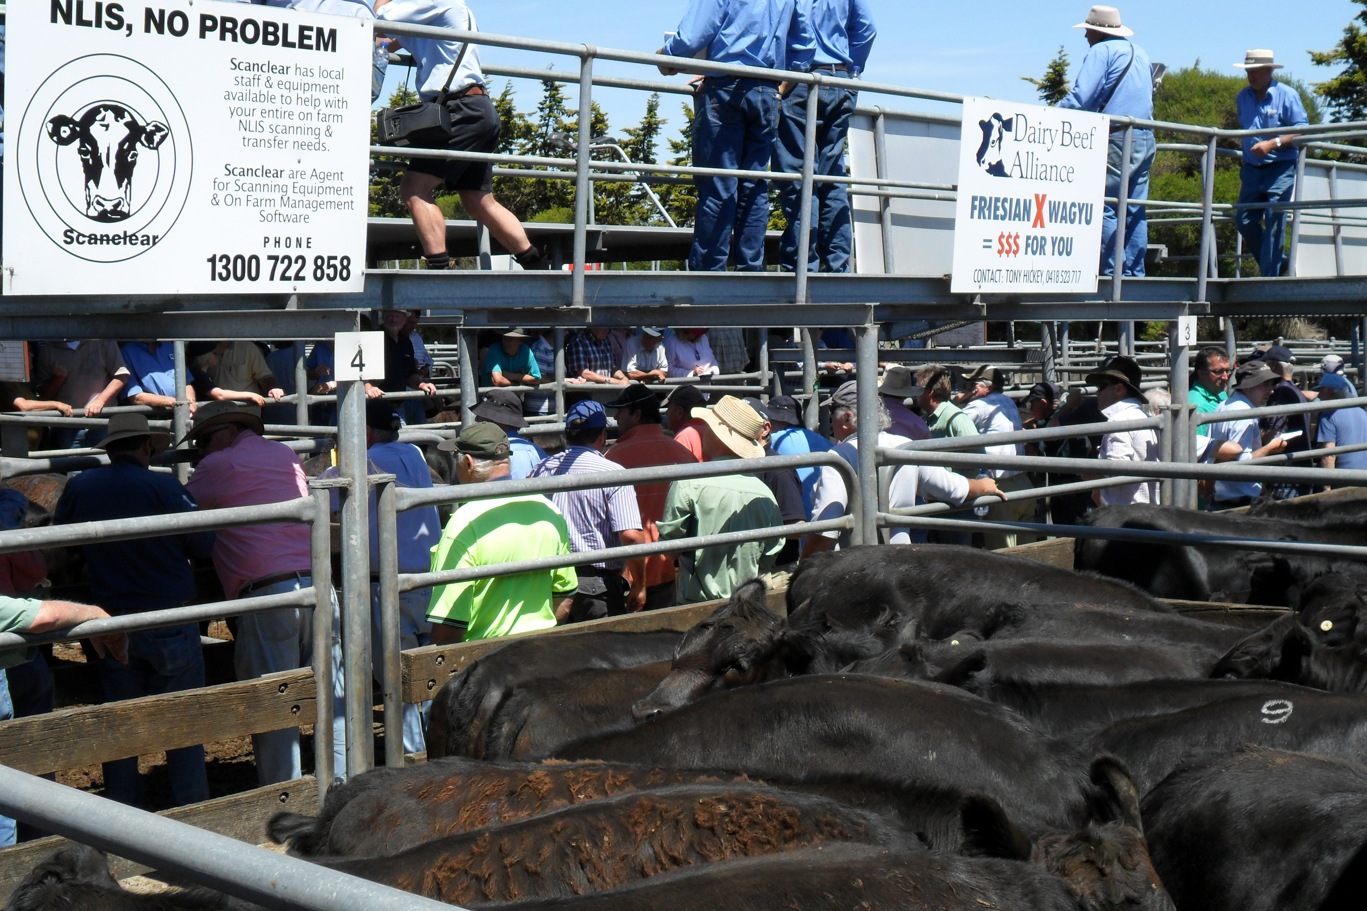
F = Fat/Prime  S = Store  D = Young Domestic | W = Weekly  FN = Fortnightly  A = As advertised  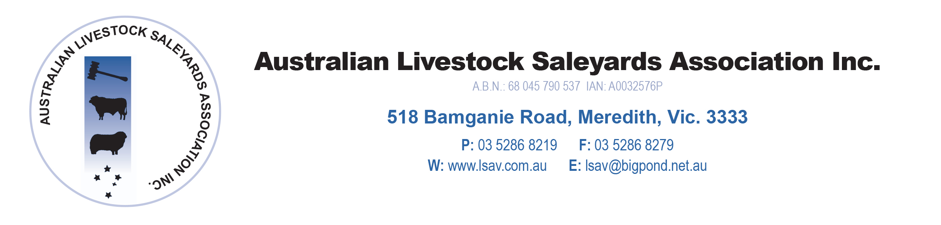 | M = Monthly  Bi M = Twice-monthly

