SOUTHERN CATTLE SALE SCHEDULE
2020/21

Monday | Tuesday | Wednesday | Thursday | Friday
Bendigo – F/W  Casterton - S/Oct  Casterton –W/Jan  Casterton – S/March & June  Casterton - Store/Oct  Shepparton – Calves/W  Echuca – S/M | Camperdown – F/W  - Stores/Dairy/A  Sale – F/W  Pakenham – F/W  Shepparton – F&S/W  Naracoorte – F/W  Adelaide Plains – F/W | Echuca – F/FN  Deniliquin/Finlay – F+S/FN  Kyneton – S/M  Euroa – S/M  Warrnambool – F & Calves  Mt Gambier – F & Calf/W  Sale – Calf/W  Mt Compass – F/W | Bairnsdale – F/W  Colac – F + Calves/W  Kyneton – F/W  Leongatha – S/FN  Pakenham – S/W  Wangaratta – F/W  Swan Hill – F/FN | Bairnsdale – S/FN  Colac – S/M  Hamilton – S/W  Sale – S/FN  Wangaratta – S/M  Mt Gambier – S/Bi M  Yea – S/M
Legend: |  |  | 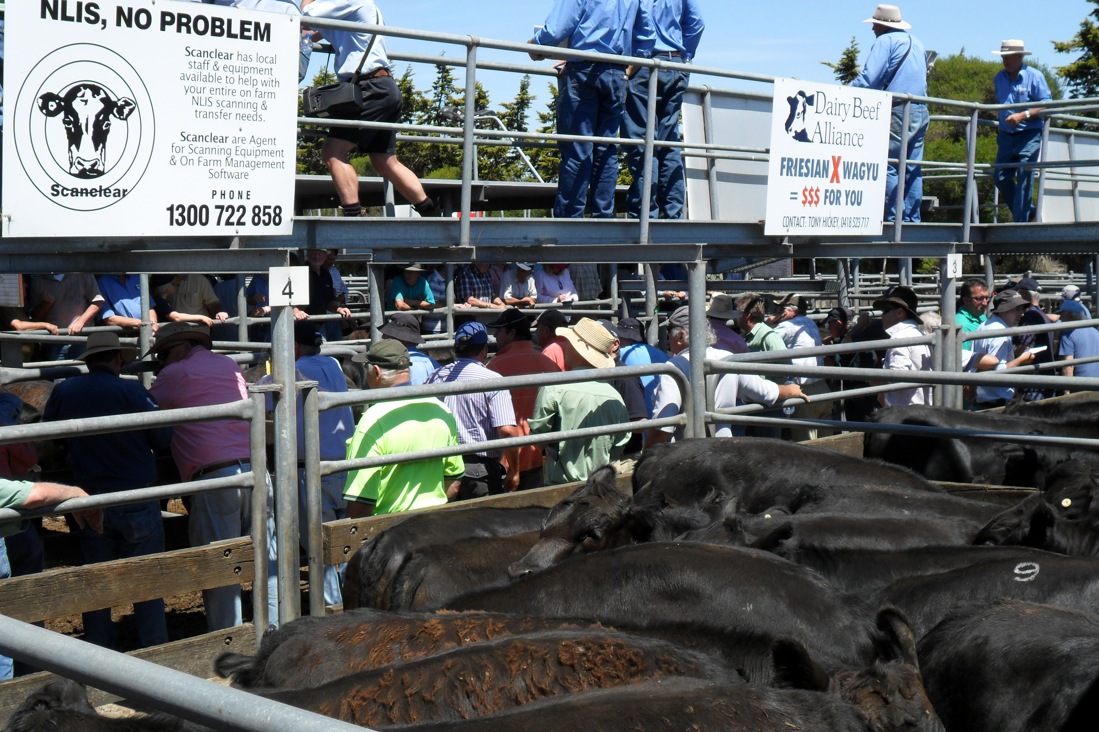
F = Fat/Prime  S = Store  D = Young Domestic | W = Weekly  FN = Fortnightly  A = As advertised | M = Monthly  Bi M = Twice-monthly

