SOUTHERN SHEEP SELLING SCHEDULE
2018/19

Monday | Tuesday | Wednesday | Thursday | Friday
Bairnsdale – Sh+L/FN  Bendigo – Sh+L/W  Hamilton – L/W (Peak-Nov & Dec 5 weeks)  Corowa – Sh + L/W | Casterton – Sh+L/Dec & Jan, 2 sales  Pakenham – Sh+L/W Sale – Sh+L/FN  Deniliquin & Finlay – Sh+L/FN  Naracoorte – S+L/W | Hamilton – Sh+L/W (all season)  Hamilton – L/W (Nov-April)  Horsham – Sh+L/W  Mt Gambier - Sh+L/W  Warrnambool – Sh+L/W  Warracknabeal – Sh+L/FN | Colac – S&L/M(4th)  Hamilton – Sh/W (Nov-April)  Kyneton – Sh+L/W  Nhill – Sh+L/Ann (2)  Ouyen – Sh+L/FN  Swan Hill – Sh/FN | Wycheproof – Sh/BiM  Shepparton – Sh+L/W  Swan Hill –  S store/A
L = Lamb  S = Sheep | W = Weekly  FN = Fortnightly  A = As advertised  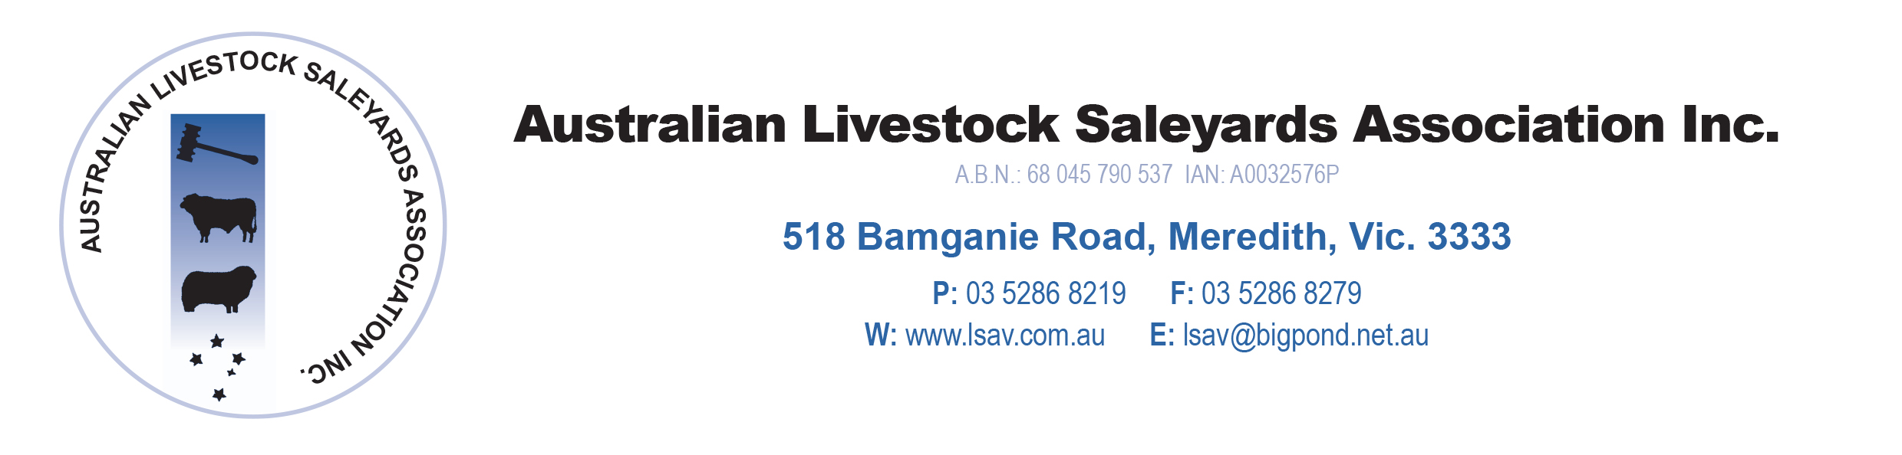 | M = Monthly  BiM = Bi-monthly | 