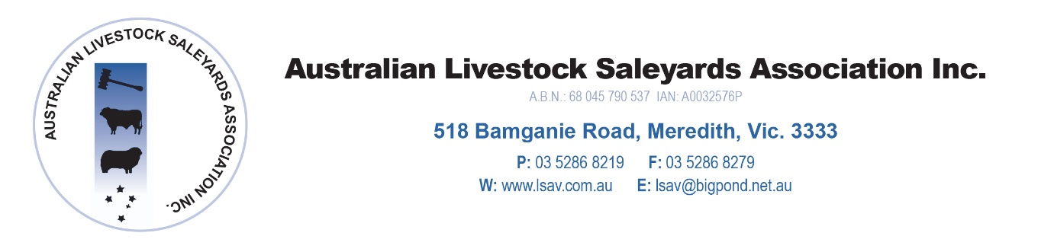

Australian Livestock Saleyards Association

Annual Conference 2018

Amora Hotel, Melbourne

PRELIMINARY PROGRAMME FOR CONFERENCE 2018

Thursday 9 August, 2018

Noon Sponsor Set Up

1.00 pm Saleyard Managers Forum – Saleyard Managers Only

1.45 pm Technical Session
- ALSA Project Update
- JBAS
- NSQA Update – NSQA
- Sheep EID Update – Ag Vic

2.45 pm AGM - Members Only

3.30 pm Afternoon Tea

4.00 pm Sponsors Presentations and ‘Speed Dating’ session

6.00 pm Sponsor pre dinner drinks

7.00 pm Conference Dinner
Stock and Land – Primary Sponsor
Dinner Entertainment – Gerard V – Comedy Hypnotist

Friday, 10 August, 2018

OPENING

8.45 am Official welcome ALSA President

8.55 am The Red Meat Digital; Strategy
MLA Speaker

9.20 am DEXA technology and Saleyard Automation
MLA Speaker

9.45 am Official Opening –
Hon Jaala Pulford – Minister for Agriculture, Victoria

10.05 am Morning Tea

Main Speaker Session

10.30 am Animal Welfare R&D – The Latest Perspective
Dr Andrew Fisher – Centre for Animal Welfare Research

10.55 am Marketing Choices and Producer Financing
Rural Bank Australia

11.20 am The ACCC Red Meat Review and Response
Mick Keogh – ACCC

11.50 am Transport Changes
NHVR Speaker

12.15 pm Lunch

1.15 pm The weather
Jane Bunn – Channel 7 meteorologist

1.45 pm Conference Close

