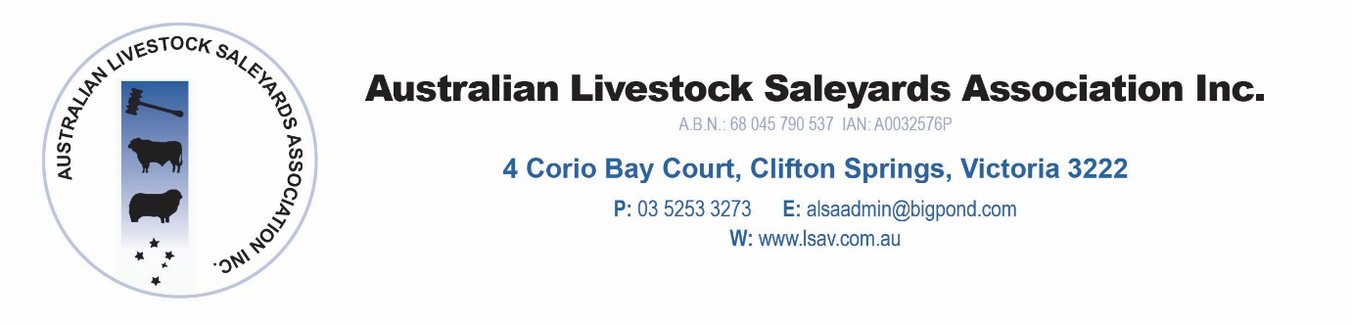

Australian Livestock Saleyards Association

Annual Conference 2019

Hyatt, Essendon Fields

PRELIMINARY PROGRAMME FOR CONFERENCE 2019

Thursday 8 August, 2019

Noon Sponsor Set Up

1.00 pm Saleyard Managers Forum – Saleyard Managers Only
- Transit stock/Ramp Standards
- Effluent Management/CoR
- Litigation

1.45 pm Technical Session
- ALSA Project Update – Mark McDonald
- Cattle Liveweight App – TBC
- NSQA Update – Ian O’Loan, NSQA
- NLIS Update – Ag Vic

2.50 pm AGM - Members Only

3.20 pm Afternoon Tea

3.45 pm Sponsors Presentations and ‘Speed Dating’ session

6.00 pm Sponsor pre dinner drinks

7.00 pm Conference Dinner
Stock and Land – Primary Sponsor

Dinner Speaker – David Parkin

Friday, 9 August, 2019

OPENING

8.30 am Official Opening –
Hon Jaclyn Symes – Minister for Agriculture, Victoria

9.00 am Official welcome ALSA President

9.10 am Weather Update
Dale Grey – Ag Vic

9.35 am Cattle Industry Update and Restructure
Cattle Council of Australia

10.00am Market Update and MLA MOU
TBC - MLA

10.25 am Morning Tea

Main Speaker Session

10.55 am Manufactured Meat – a new competitor
TBC

11.20 am Blockchain – threat or benefit
Blockchain Australia

11.45 am Sheep RFID – The road to nationalization – Panel Session

Speaker Presentations
Len Vallence – VFF
TBC – Ag Vic
TBC- Sheep Producers Australia
TBC – PIRSA
TBC - ALSA
Panel discussion

1.00 pm Lunch

1.45 pm Conference Close

