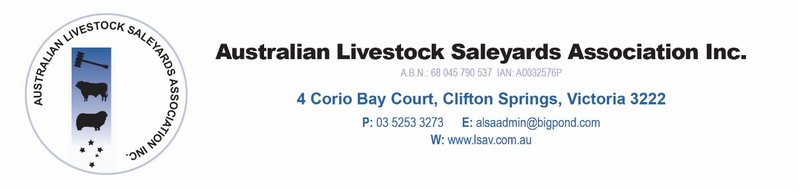

Australian Livestock Saleyards Association

Annual Conference 2019

Hyatt, Essendon Fields

PRELIMINARY PROGRAMME FOR CONFERENCE 2019

Thursday 8 August, 2019

Noon Sponsor Set Up

1.00 pm Saleyard Managers Forum – Saleyard Managers Only
- Transit stock/Ramp Standards
- Effluent Management/CoR
- Saleyard Litigation VLE

2.10 pm Technical Session

- ALSA Project Update – Mark McDonald
- NSQA Update – Ian O’Loan, NSQA
- NLIS Update – Ben Fahy, Ag Vic

2.50 pm AGM - Members Only

3.20 pm Afternoon Tea

3.45 pm Sponsors Presentations and ‘Speed Dating’ session

6.00 pm Sponsor pre dinner drinks

7.00 pm Conference Dinner
Stock and Land – Primary Sponsor

Dinner Speaker – David Parkin

Friday, 9 August, 2019

OPENING

8.30 am Official Opening and Welcome

ALSA President

8.45 am Weather Update
Dale Grey – Ag Vic

9.10 am Online Selling Interface for saleyards
Michael Corcoran – Auctions plus

9.35 am Cattle Industry Update and Restructure
Tom Dawkins - Cattle Council of Australia

10.05am Blockchain – threat or benefit to the industry
Ralph Kansai - Blockchain Australia

10.40 am Morning Tea

Main Speaker Session

11.05 am Manufactured Meat – a new competitor
Dr James Ryall – Melbourne University

11.30 am Activism and how the industry is tackling it
Jax Bapista - MLA

12.00 am Sheep RFID – The road to nationalization – Panel Session

Speaker Presentations
Len Vallence – VFF
Ben Fahy – Ag Vic
Stephen Crisp- Sheep Producers Australia
TBC – ALSA
TBC - Processor
Panel discussion

1.15 pm Lunch

1.55 pm Conference Close

