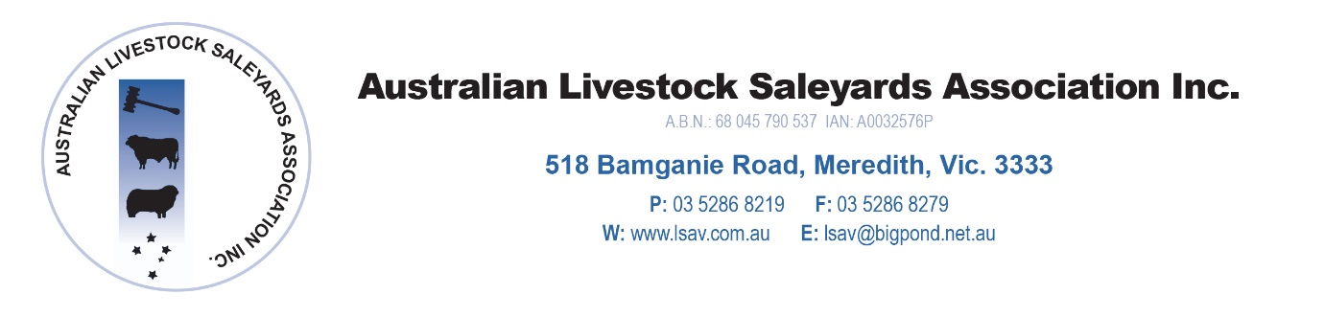

10th April 2018

GOVERNMENT DECISION ON SHEEP RFID VINDICATED.

Last week the Victorian saleyard sector entered a new era with the compulsory introduction of sheep RFID becoming a reality and scanning taking place for the first time. Based on feedback from Victorian saleyards who have scanned over the last 2 weeks the new process has been incorporated into the saleyard practices smoothly. This has included reading using fixed scanning equipment as well as portable hand scanners.

This successful introduction follows the announcement by the state government in August 2016 that Victoria would be the first state to introduce compulsory sheep scanning. This included funding to ensure saleyards had the correct hardware and software to capture and manage the sheep RFID data and integrate with the NLIS database.

The ALSA board would like to congratulate the government and Minister Pulford for making this industry changing decision and the outcome from the first 2 weeks of scanning vindicates this decision despite initial industry scepticism that the system would not be practicable. Once again Victoria has lead industry into a new era as was the case with the introduction of RFID for cattle.

Mr McLean (ALSA President) stated that ‘The introduction of the compulsory sheep scanning will be a benefit to the Victorian livestock sector for many years to come and will ensure greater transparency for transactions, animal traceability and biosecurity management. It is only a matter of time before the system becomes a nationwide practice which will ultimately be of benefit to the marketing of Australian lamb and mutton on the international marketplace.’.

ALSA board and members have been a long term supporter of sheep RFID and has been involved in the roll out process with its members throughout Victoria. We expect that the system will progressively become more efficient once all parties get used to operating the hardware and associated software. We expect that the overall saleyard administration will also become more efficient with the introduction of new software systems and hand held devices for saleyard operators. Hopefully electronic NVD’s will become integrated into saleyards in the near future to complete this digital upgrade for the sector. This will help ensure that saleyards remain a viable selling option for producers well into the future by being part of the digital infrastructure for the red meat industry.

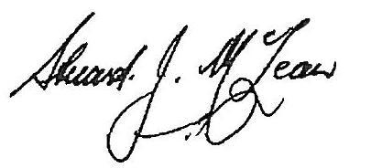

Mr Stuart McLean OAM
President
Australian Livestock Saleyards Association

