December 10 2020

ALSA / UTS AUTOMATED SHEEP COUNTING TRIAL

BACKGROUND:

ALSA had invited the UTS team to demonstrate the automated animal counting system at The Bendigo saleyards. The aim of the trial was to ascertain the potential use of the system within a saleyard environment. In particular the accuracy and potential locations within a standard saleyard.

The system is currently operating for the loading of live export sheep in WA and will be commercialized in the future to a range of animal industries.

METHODOLOGY:

The UTS provided 2 pole based systems for use in the trial. These were to be tested at various saleyard locations. The system required power for operation and the test units were man portable if required (see photos).

Transporters were asked to back into the 2 ramps covered by the cameras on day one. On the sale day one camera was located in one delivery lane leading to the post sale holding pens.

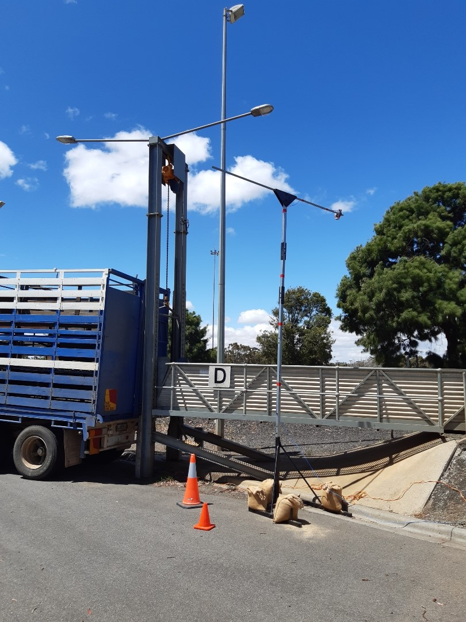

Around 10-12 trucks were covered on day one. Some of these had multiple NVDs’s on the load whilst others were a single NVD. The totals varied from mid to low 100’s to over 500 head from one truck.

Around a dozen animal movements were captured on day 2 plus some additional testing with a new set up. The width of the day 2 trial video capture area was around 1.5 metres compared with 900mls for the ramps on day one.

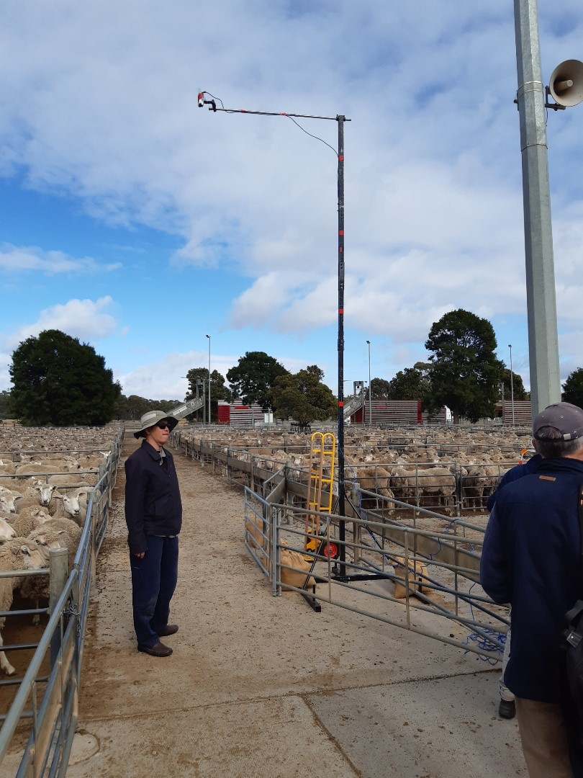

The weather for both days was relatively unseasonable with temperatures in the high teens, overcast and occasional showers. On the second day there were occasional bursts of sunshine but generally similar to the previous day.

BENDIGO TRIAL Dec 6/7:

The system was trialled in both a pre-sale and post-sale arrangements. The former was based on ramps used for unloading stock (pre sale) whilst the later was situated within a saleyard deliver lane to capture post sale movements of animals to holding pens. We did not test the system for the loading of trucks post sale as this is already operating successfully in the live export market.

Day 1: Transport Unloading

The system was installed on 2 adjacent ramps. Transporters were encouraged to unload at these ramps so the data collection could be undertaken. This was positively received and only 1 transport refused to participate. Most were interested to compare their results with the numbers they either counted on or had on the NVD.

The totals were collected for each shipment and then compared with the NVD figure and the drover’s total. In a number of cases there were discrepancies between all three totals. Post sale analysis of the figures indicated that the UTS result was the correct figure in at least 3 cases.

The results from the day 1 testing indicated an almost 100% accuracy for the UTS system. The system was able to process multiple NVD’s from the same vehicle and identify the totals for each lot.

Day 2: Delivery Pens

One camera was installed in a delivery lane to capture post sale movements out of the sale pens. The set up included a choke point to reduce the laneway size to around 1.5 metres. This did not adversely impact the sheep flow. Almost immediately we had discrepancy outcomes between the drover totals and the UTS system. The drover figures would be 100% correct in this situation as they are based on the sale pen totals.

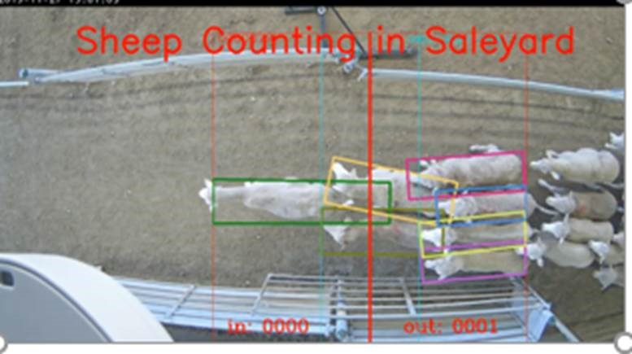

These were usually only 1 or 2 head difference compared with the drover totals (on runs of up to 200 head). However, in one case the difference was almost 3% less for a large run of 750 plus lambs. The UTS team reviewed the video data of these runs and believed that the issue related to the colour of the concreate base of the run and possibly the width of the capture point.

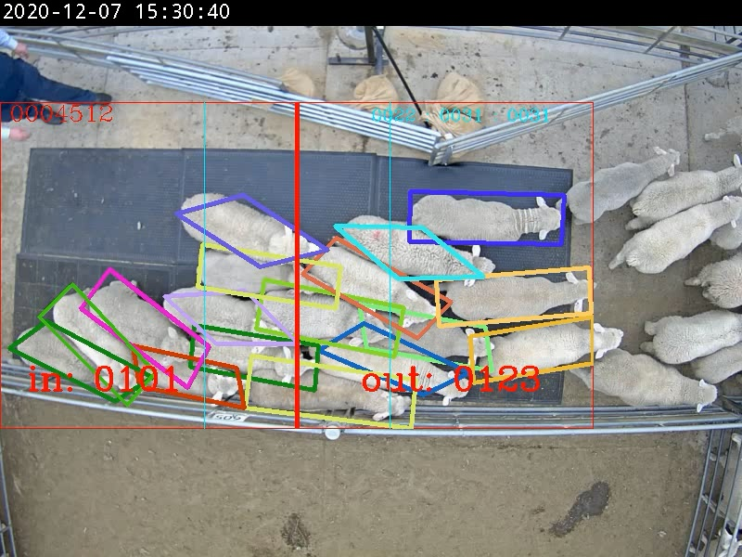

Subsequently they purchased some black rubber flooring and laid this in the capture point. A trial with 123 sheep was undertaken in both directions to test the new arrangements which resulted in 100% accuracy on all runs. This was a key finding from the day 2 trial.

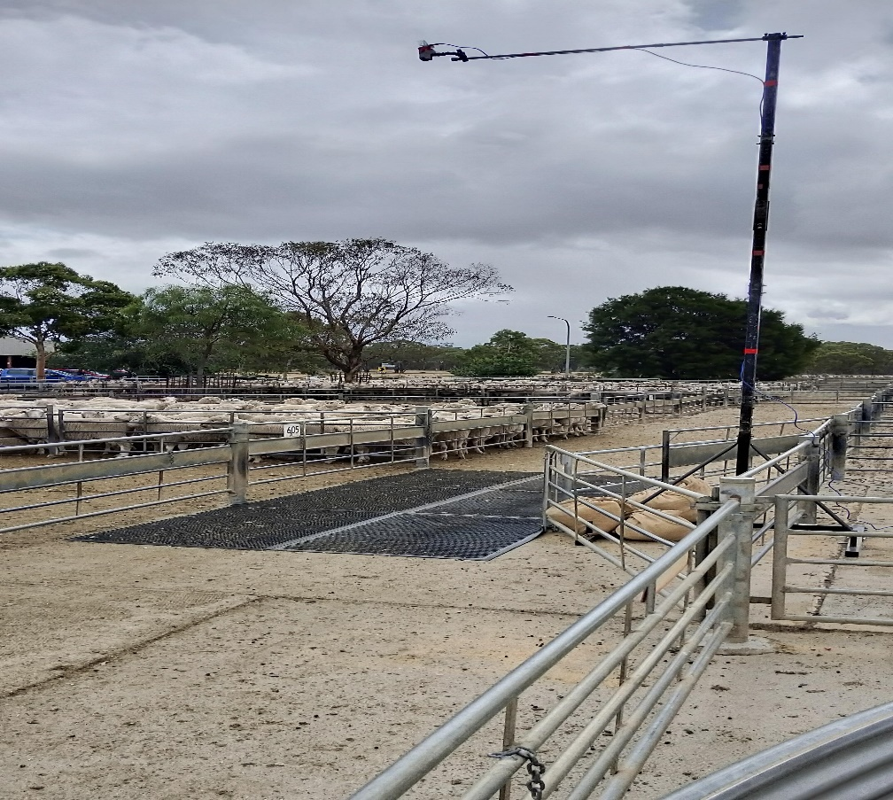

The UTS team also trialled a single pen video capture test. This would allow a single video of a pen to be used for counting the numbers. This would be limited to smaller pen sizes like sale pens. This was completed successfully.

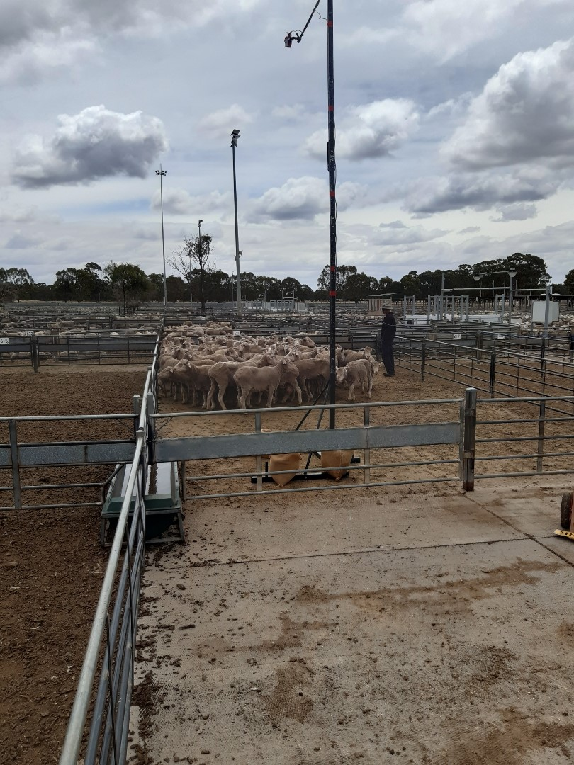

There was also consideration of issues like animal flows and parking that might have affected the results. In at least one case sheep remained static under the capture point for some time with resultant milling around in this area. We were not able to ascertain if this affected the counting results but is quite a common outcome in the post-sale logistics. This is an area that could be tested again in future trials.

The design of the capture area in a fixed installation would also need to be considered. The simple arrangement used at Bendigo could be enhanced to make the animal flow more regular with less bunching of stock at the choke point.

SUMMARY:

Once the issue with the concrete reflection within the delivery lane had been addressed this trial successfully demonstrated the use of the UTS system as a means to count sheep within a saleyard situation. This resulted in an almost 100% accuracy outcome for all sheep movements.

The key finding from day one indicated that the UTS system was more accurate than NVD and drover totals in a number of cases. The true figure is eventually captured in the scanning/penning process undertaken pre sale so these differences are not as critical at the point of delivery.

A key finding on day 2 related to the reflection impact of the concrete walkway and the possible width of the capture point below the camera.

Feedback from local saleyard workers was also generally positive and the addition of this sort of technology in the future was seen as a potential benefit to aid the current saleyard processes.

POTENTIAL FUTURE ACTIVITY

Given the success of the trial a number of potential future activities can be considered. This would extend beyond the scope of the Bendigo trial. These include:

- Retest the system within the saleyard using the new matting coverage. Potentially test in a yard with overhead coverage.

- Explore potential use on the drafting infrastructure (link a photo to the individual animal).

- Consider additional features from the UTS technology stable that include security provisions, weight estimation and logistical planning for animal movements.

- Consider possible linkages to saleyard systems and other data available on site eg. RFID data.

ALSA would like to thank both UTS and the Bendigo saleyards for their support for this trial which will be of value for the sector moving forward.

Mark McDonald
Executive Officer ALSA
alsadmin@bigpond.com
0422 312607

