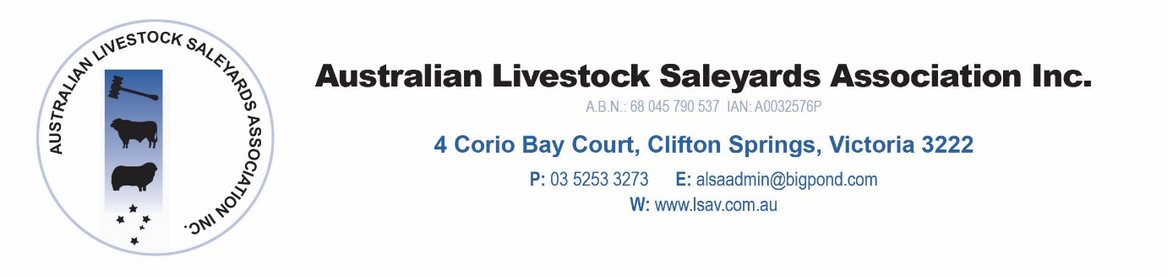
ALSA Web Site Membership Template

Saleyard:
- Bairnsdale Livestock Exchange
Contact Person: (name, role)
- Taylah Rae Robinson - Coordinator
- Mal Leys – Senior Operations Officer
Contact details: (Address, phone, email)
* Mobile 0439 174 129 – Taylor
Mobile 0417 707 540 – Mal
Office 03 51 539 500
Sale Days: (Day, time, animal type, sale type)
* Thursday weekly – Prime Cattle 9.00am
2nd and 4th Friday – Cattle Store sale 11.00am
Fortnightly Monday Sheep sale – 11.00am
Special Calf sale – March and August
Selling Agents: (company, contact, phone)
- Elders 03 5153 6100
Biil Wyndham & Co 03 5153 0533
Landmark EGL 03 5153 1144
Sharp Fullgrabe 03 5152 6411

Facilities: Describe facilities you provide, eg. Truckwash, canteen etc
* 2 Bay truck was, Avdatas and token
Kiosk
Showers/Toilets
2 Weigh Bridges
Fully roofed, soft floors
General comments: Add further information if required.
* NSQA, MSA and EU accredited

