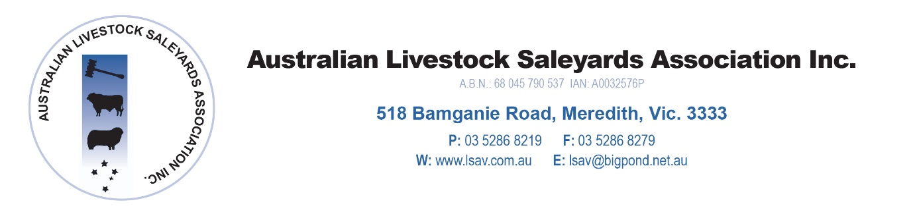

3rd April 2018

PRESS RELEASE – Vale David Pollock

The ALSA and NSQA regret to advise that Mr David Pollock passed away on Thursday March 29 after a short illness.

David had a long standing involvement with the industry including a range of roles over the last 25 years. These include:

- LSAV executive Officer (now ALSA)
- EO for the agents association
- EO for NASSO
- Founding board member for NSQA and EO
- EO for livestock transporters
- EO for NCWSBA (wool industry).

He only recently stood down from the NSQA role which was his last industry position. and was looking forward to a well earned retirement. Mr McLean stated that ‘He has left a strong legacy that most industry participants will not be aware of given his role in the background with the organizations listed above’.

Mr O’Loan said ‘He was a quiet achiever who always operated in a professional manner to push industry forward. This included the creation of NSQA, the introduction of a comprehensive OH&S system for saleyards and the management of a number of industry events and conferences’.

Vale David, a job well done and an unsung champion for industry.

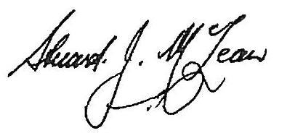

Mr Stuart McLean OAM
President
Australian Livestock Saleyards Association

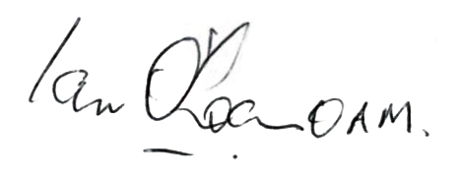
Mr Ian O’Loan OAM
President
NSQA

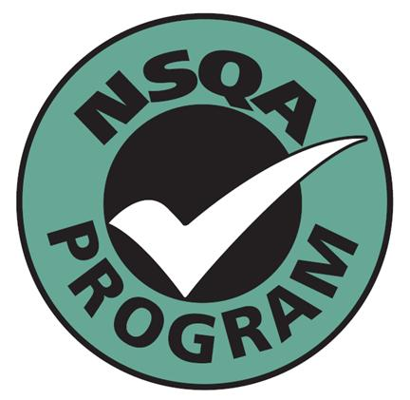
NSQA
National Saleyards Quality Assurance Inc.
ABN: 76 657 458 542

